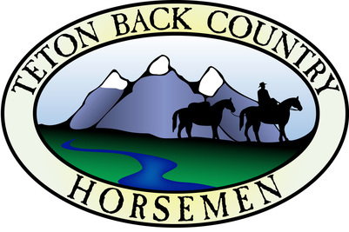
Teton Back Country Horsemen 2023 Rendezvous Registration
2023 Wyoming Back Country Horsemen Rendezvous Registration,
hosted by Teton Back Country Horsemen
Thursday – Sunday Aug 3^{rd -} 6^{th,} 2023
REGISTRATION FORM:
Registration with signed Liability Release Forms must be received by July 30^{th.}
(No refunds after July 30th)
*Required

- * Application Date: _______________________

- * Last Name: ____________________________

- * First Name: ____________________________

- Name of other people in your party: Please include the ages of any children for appropriate meals.:

_________________________________ _______________________________________

_________________________________ _______________________________________

- * Mailing Address: ________________________________________________________

- * City, State, Zip Code: _____________________________________________________

- * Email: _________________________________________________________________

- * Phone Number: ________________________

- Please describe how you plan to camp: _____________________________________
_____________________________________________________________________
_____________________________________________________________________

- Please describe your rig: (length of trailer, box, or flat bed, etc. Ground in uneven in places and we want to make sure we can accommodate you.):

____________________________________________________________________________________

11. * The camping/parking area is numbered. Pick a number: ________________________

- Do you plan to arrive before the check-in time of 12:00 noon, Thursday August 4th? Yes / No
Please indicate your arrival date/time so we can accommodate you. _________________________

13. Number of livestock: _____________________

14. Will you bring an ATV? ____________________

15. Total number of vehicles, trailers atv’s in camp: ______________________________

16. Choose your ride: Monitored sign ups
____ #1 Ride – Description and map to be added
____ #2 Ride – Description and map to be added
____ #3 Ride – Description and map to be added

Registration is $75 per person (per single adult) which includes Saturday dinner and Sunday breakfast, portable toilets, USFS permit and liability certificate fees.
Payment can be completed using Paypal (use email address TetonBCH@outlook.com as recipient) or through the mail (PO Box 10841, Jackson WY 83002.
Email this registration form to TetonBCH@outlook.com.

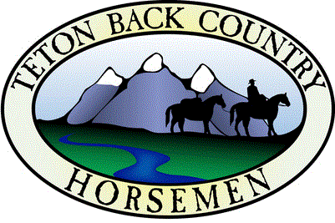
GUEST RELEASE
I/We understand that under the Wyoming Recreation Safety Act (W-S-1-1-121), any individual who rides a horse in this state does so at his or her own risk and that the individual rider is liable for any damages, including death, which might occur on, or arising from, the ride.
In consideration for the privilege of riding with the Teton Back Country Horsemen (TBCH) on one of its sponsored trail rides, I hereby release and immunize from any liability for damages to me, to my children, to my guests, or to our horses, which might attach as a result of, or in connection with, that ride both TBCH and the landowners (including the United States Government), through whose property we may be riding.
TBCH is expressly defined to include the Back Country Horsemen of Wyoming, Inc., as well as its Teton County Chapter and that chapter’s officers, directors, and members.

Date_________________________________

_______________________________________ _____________________________________
Signature #1 Printed Name

_______________________________________ _____________________________________
Signature #2 Printed Name

_______________________________________ _____________________________________
Signature #3 Printed Name

_______________________________________ _____________________________________
Signature #4 Printed Name

_______________________________________ _____________________________________
Signature #5 Printed Name

_______________________________________ _____________________________________
Signature #6 Printed Name

Please print more Guest Releases if more signatures are necessary

